Internship assignment task 2

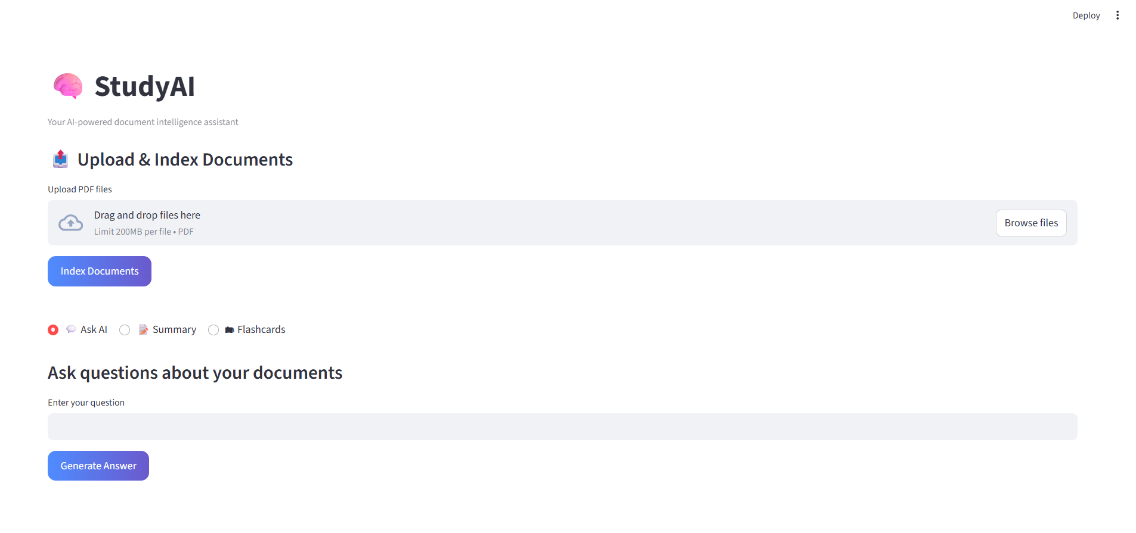
Figure shows the UI of study AI, where users can input their documents and ask questions, generate summary and flashcard regarding the documents.
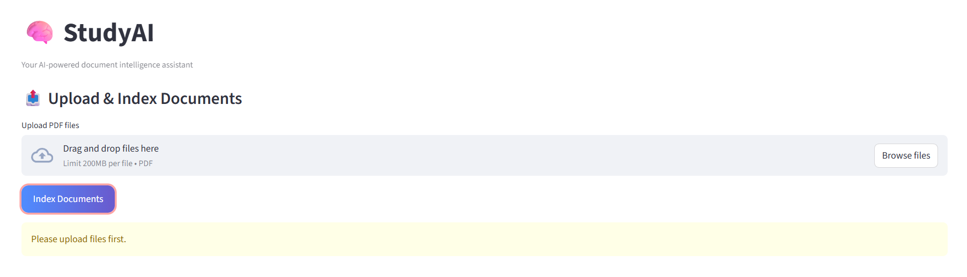
Figure shows the error if the user has not upload the documents before indexing (processing) the document.

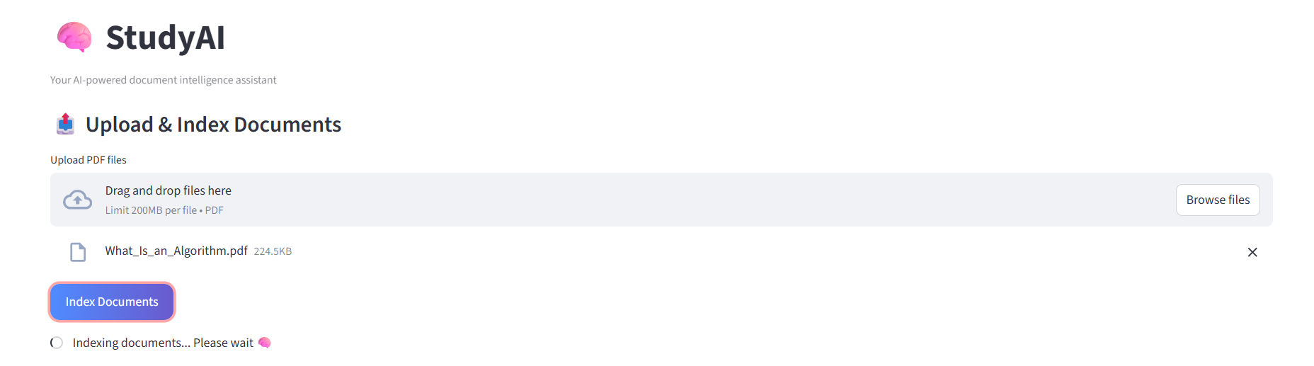
Figure shows the documents being processed with a spiner indicating that the document is being processing.

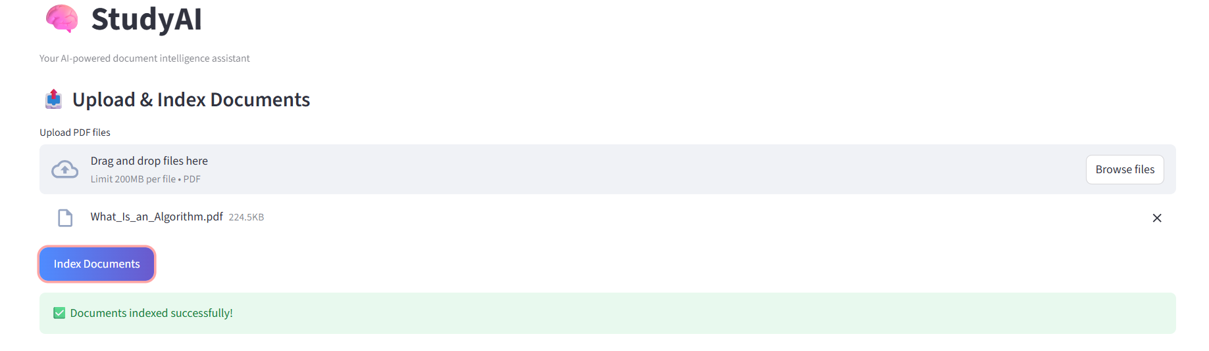
Figure shows the documents have finished processing.

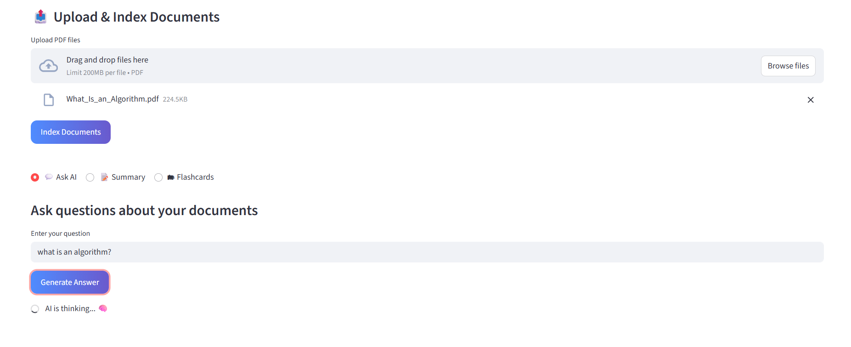
Figure shows the user’s question “what is an algorithm” into the AI (ollama) while the ai is processing the answer.

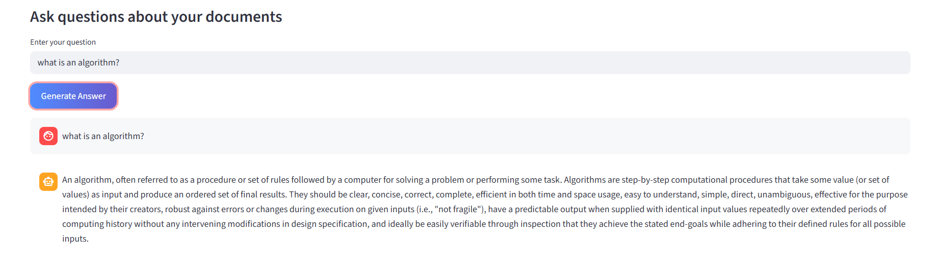
Figure shows the answer given from the AI (ollama).
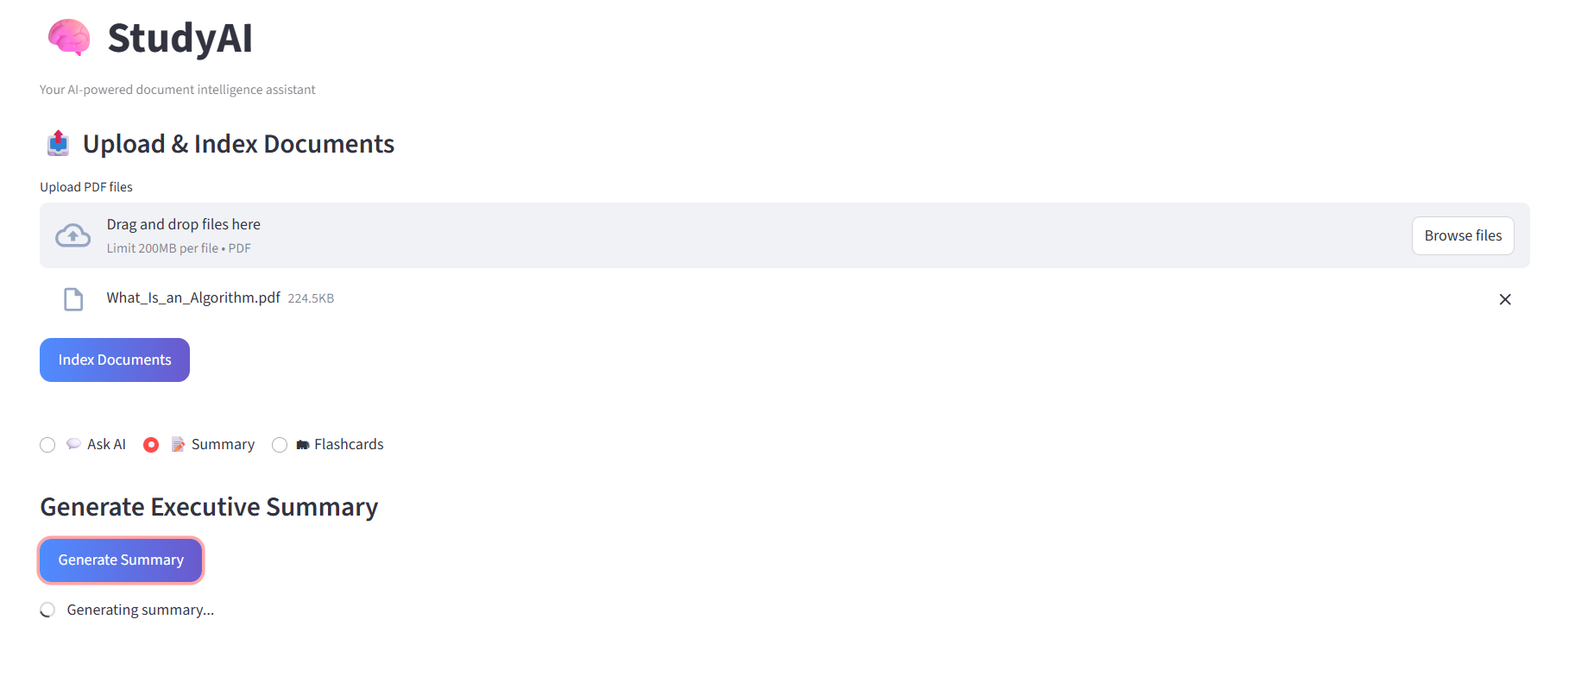
Figure shows the generate summary tab, which shows a button to generate the summary of the pdf input by the user. The summary is currently being generated, shown by the spinner underneath the generating summary button.

Figure shows the error connection time out when the summary took too long to load. This happens when the file is too big to be processed.
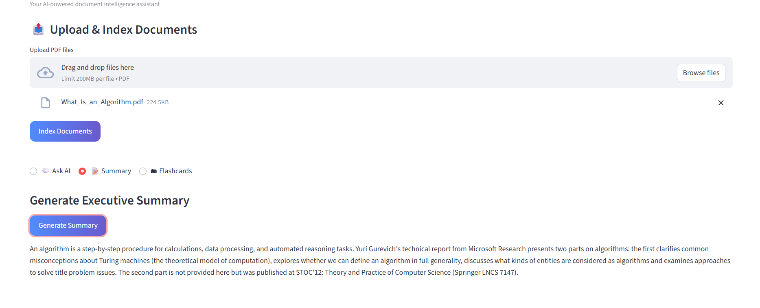
Figure shows the output of the generated summary of the document.
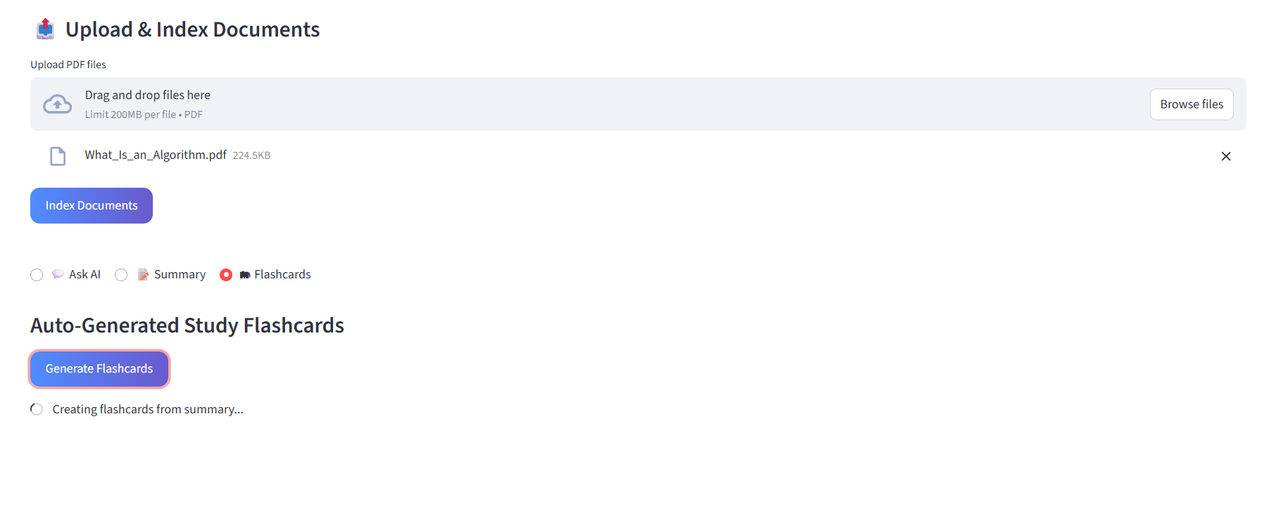
Figure shows the flashcards being processed shown by the spinner under the generate flashcards button.
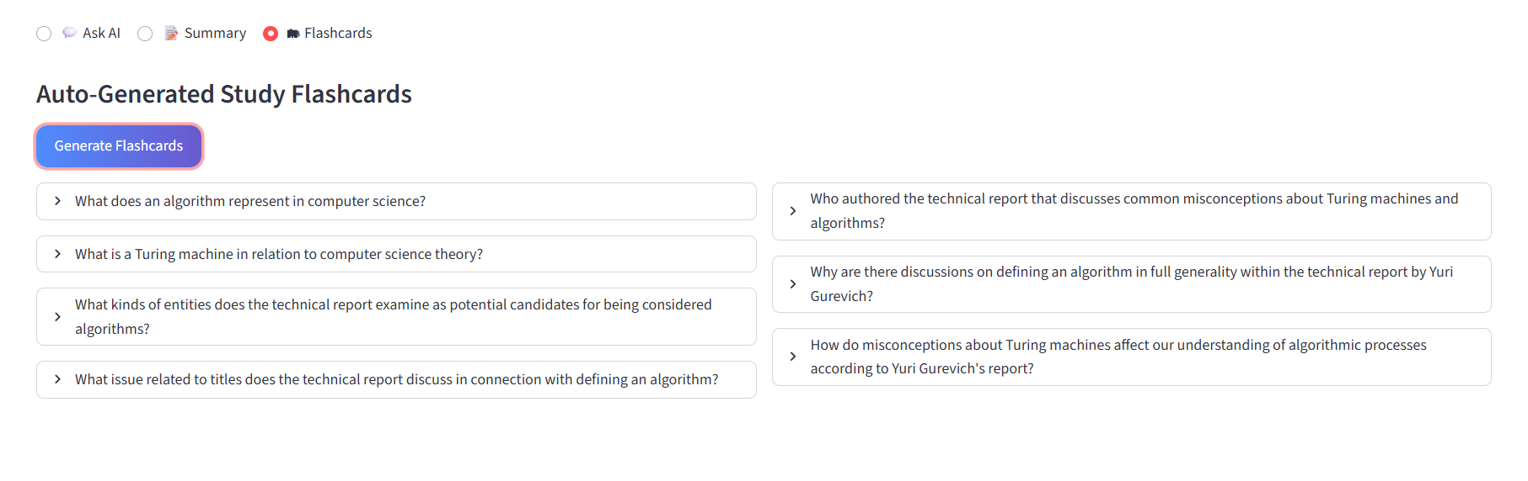
Figure shows 7 questions being generated out. The user can click on the arrow beside the question to see the answer that was hidden.
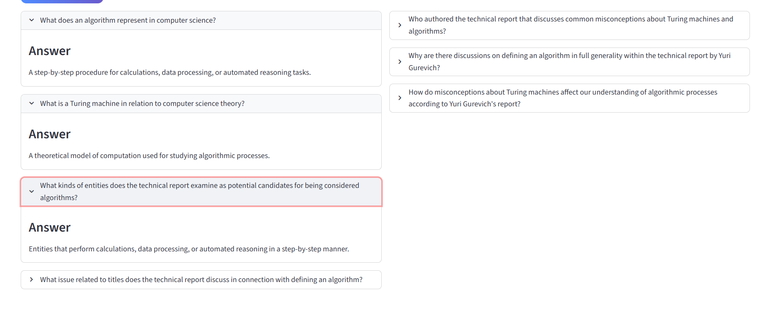
Figure shows the answer of the questions generated by the flashcards.

